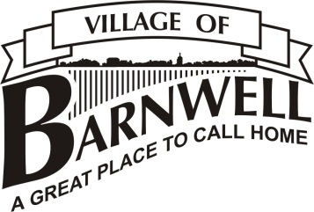
IMPORTANT
NOTICE

REMEMBRANCE DAY GARBAGE PICK-UP SCHEDULE CHANGE

Garbage pick-up for Nov 11th, 2017 has been changed to

FRIDAY, NOVEMBER 10, 2017

Regular pick-up is scheduled for
SATURDAY, NOVEMBER 18TH, 2017

This change was made due to the Taber Landfill Holiday Hours.
RECYCLING WILL REMAIN THE SAME FOR
NOVEMBER 11TH , 2017

